2012 WHITE OUT T-Shirts
Friday September 28th
^{vs. Harrington}
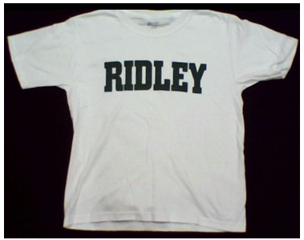
$6 each
3 for $15
--------------------------------------------------RETURN BOTTOM PORTION-------------------------------------------------

Youth sizes: Small _______ Medium _______ Large _______
Adult sizes: Small _______ Medium _______ Large _______ XL _______
$7 each : XXL _______ XXXL_______ Total Cost: _______
Name: __________________________ School:__________________________
Teacher: _________________________ Grade: _____ Room Number: ________
Address___________________________________________________________
CONTACT Phone # H/C____________________________________
Make Checks payable “Ridley Football Boosters”
Can be mailed to Po Box 271 Folsom, Pa. 19033

Return ASAP no orders accepted after Friday September 21st

